**Alaa Eldewer**

**Asmaa Mahfouz**

**Mohamed Taha**

**Shorouk Atef**

**Seif Allah Hassan**

**supply chain analysis**

**Executive summary**

## Motivations:

1. Analyze supply chain data to identify root causes of increased downtime and defects.
2. Analyze supplier behavior, lead times, and the state of supplied materials.
3. Forecast potential increases or decreases in vendor defects.

# Key Finding:

1. An increase in defect quantity is linked to vendor downtime.
2. Top 10 vendors supply the highest number of defects.
3. The worst five vendors have the highest downtime.
4. Illinois has the highest defect quantity in the USA.
5. Raw materials contribute the highest defect quantity.
6. The highest defect quantity from vendors occurred in October 2014.
7. The percentage of defects categorized as "No Impact" was the highest in 2013 and 2014.

# Important Insights:

1. This data covers a total of 326 vendors, which was divided into 162 in 2013 and reached 287 by 2014 attempt to grow or decrease the defect quantity.
2. The rise of downtime from 45% in 2013 to 55% in 2014 resulted in a proportion of the defect quantity increasing from 42% in 2013 to 58% in 2014 due to transportation delays, inventory issues, and supply chain disruptions.
3. The percentage of rejected quantity has significantly increased, from 25.5% in 2013 to 29.5% in 2014 due to the defect quantity increase.

# Recommendation:

1. **Vendor Performance Monitoring:** Implement a vendor performance dashboard to track defect quantities and downtime. Compare year-on-year performance and focus on the top 20% of vendors contributing to defects. Develop targeted vendor improvement plans or consider replacing consistently underperforming vendors based on the standard criteria.
2. **Downtime Reduction Initiatives:** Since downtime significantly increased from 45% to 55% and correlates with defects, implement root cause analysis to pinpoint transportation and inventory bottlenecks. Invest in predictive analytics and real-time data solutions to anticipate supply chain disruptions and mitigate delays.
3. **Rejection Rate Control:** The increase in rejected quantities indicates quality control issues. Strengthen quality assurance programs by:

* Conducting regular supplier audits
* Implementing stricter incoming material inspections
* Offering training and incentives to vendors for defect reduction.

1. **Data-Driven Supply Chain Optimization:** Analyze the growing number of vendors (from 162 in 2013 to 287 in 2014) to determine the impact on defect rates. Use data analytics to find optimal vendor numbers that balance supply chain efficiency with defect control. Consider consolidating vendors with proven low defect rates to enhance control.

**Introduction**

# Objectives:

1. Examine supply chain data to determine the root causes of increased downtime and defects.
2. Investigate vendor behavior, lead times, and the condition of provided materials.
3. Predict possible increases or declines in vendor faults.
4. Understand who the best and worst suppliers are, concerning quality.
5. Identify which plants do a better job finding and rejecting defects, to minimize downtime.

# Questions and answers:

* 1. What percentage of defects can be attributed to the top 10 vendors?
* Vendor concentration in defects: 46% of total defect quantity is supplied by just 10 vendors, with a significant impact from vendor downtime.

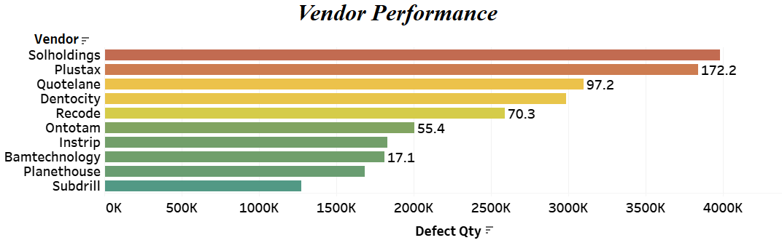

* 1. Which state is the greatest defect quantity, and what are the contributing factors?
* Illinois’ major role in defects: Illinois, with 190 vendors, contributes the highest defect quantity (22.7 million), driving a 647-hour increase in downtime. This is tied to Illinois' diverse economy, including finance, agriculture, and manufacturing.
  1. What are the reasons behind the increased risk of regional instability?
* **Regional defect risks:** The Midwest’s industrial belt, with its long supply chains and complex manufacturing, is prone to higher defect rates due to the complexity of products.

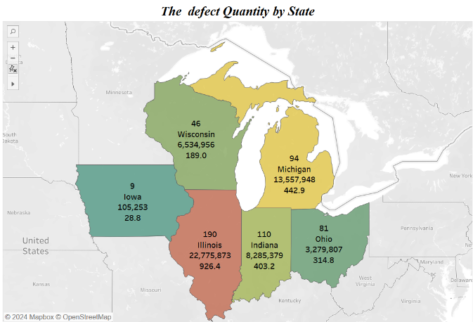

* 1. Which downtime category occurs most frequently and has the greatest impact on operations?
* 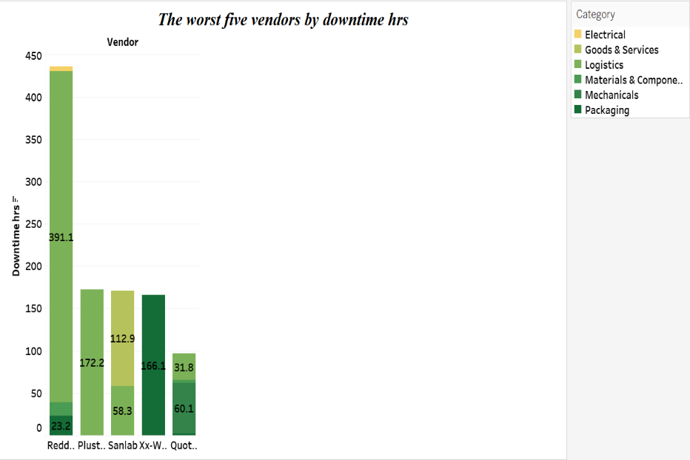Logistics as a downtime driver: Logistics, affected by transportation delays, inventory issues, and supply chain disruptions, account for the most downtime hours.
  1. What is the biggest state in downtime and in which category?
* Illinois logistics delays: Delays in Illinois account for 39% (250 hours) of downtime, largely due to logistical challenges.

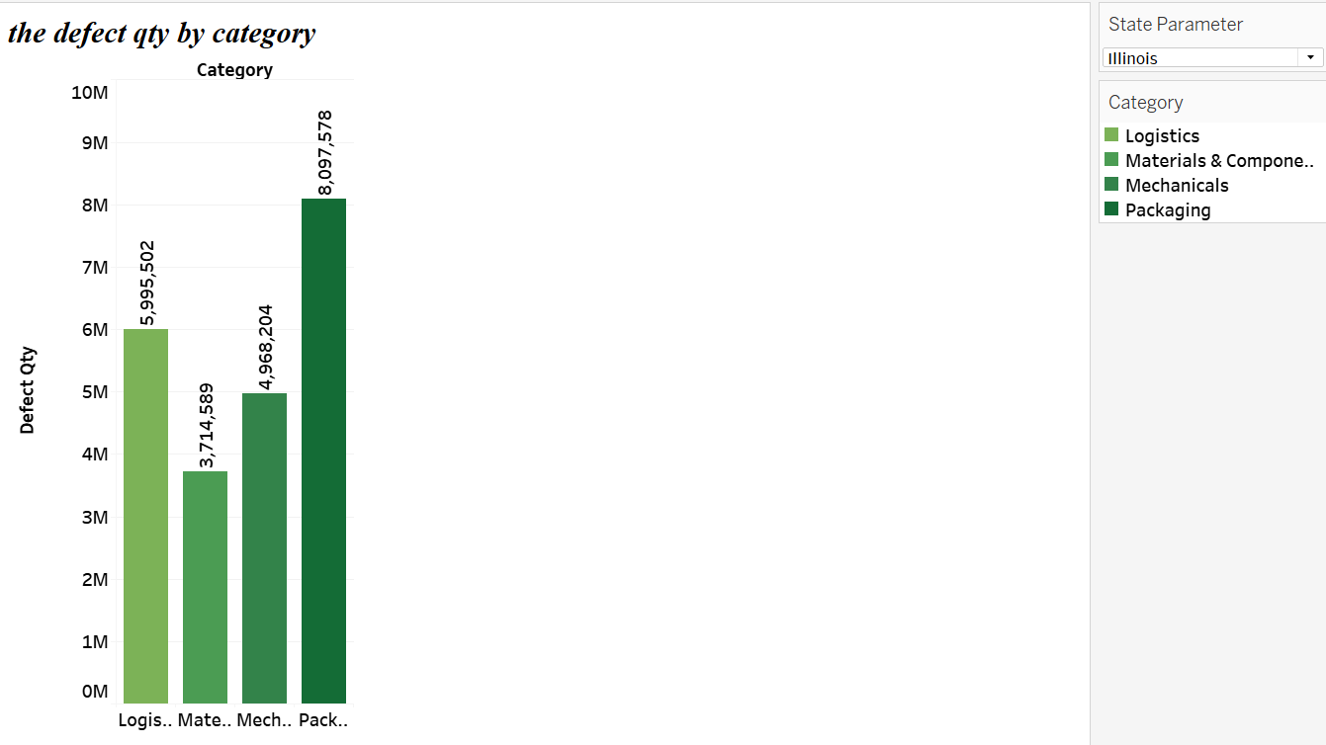

* 1. Why are mechanical and Logistics defects sources of failures in some States?
* **Mechanical defects:** Mechanical issues are the leading source of defects, especially in states like Michigan, Indiana, and Ohio, which are hubs for automotive and aerospace manufacturing.
* **Logistics defects:** affected by transportation delays, inventory issues, and supply chain disruptions, account for the most downtime hours and consequently affect defect quantity.

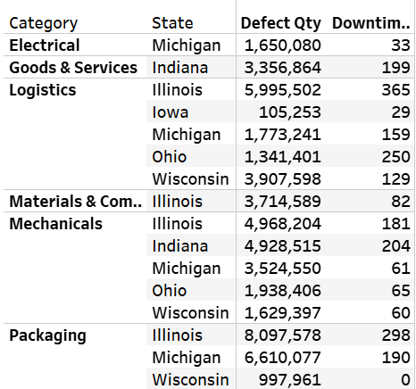

* 1. What is the description of the quarterly trend between production stopped and production volume?
* **Quarterly defect trends:** Defect quantities and downtime peak in Q3 and decline in Q4, indicating a correlation between increased production volume and downtime.

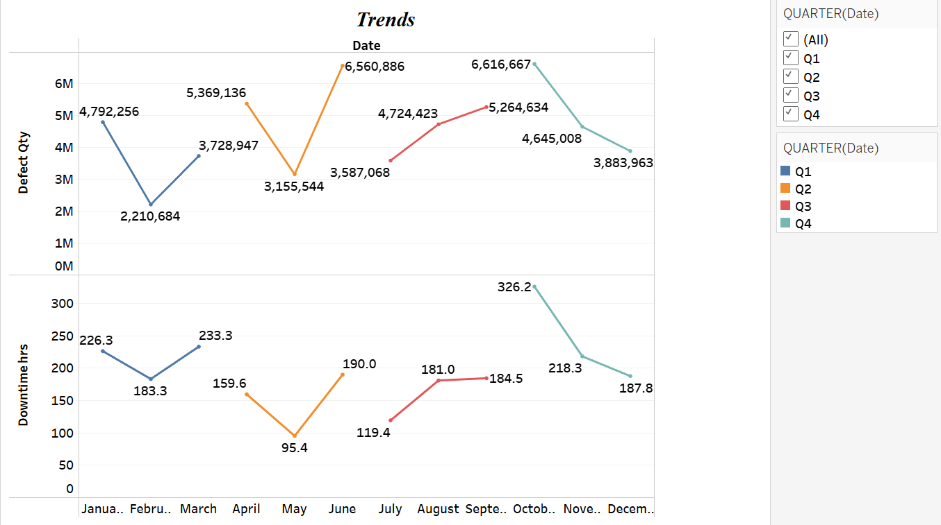

* 1. What are your most important observations about vendor performance regarding downtime and defect quantity?
* Unique vendor performance: Subdrill, a vendor in Indiana, maintains zero defects and downtime over three supply orders, whereas Coniums has the highest defect quantity in a single order.

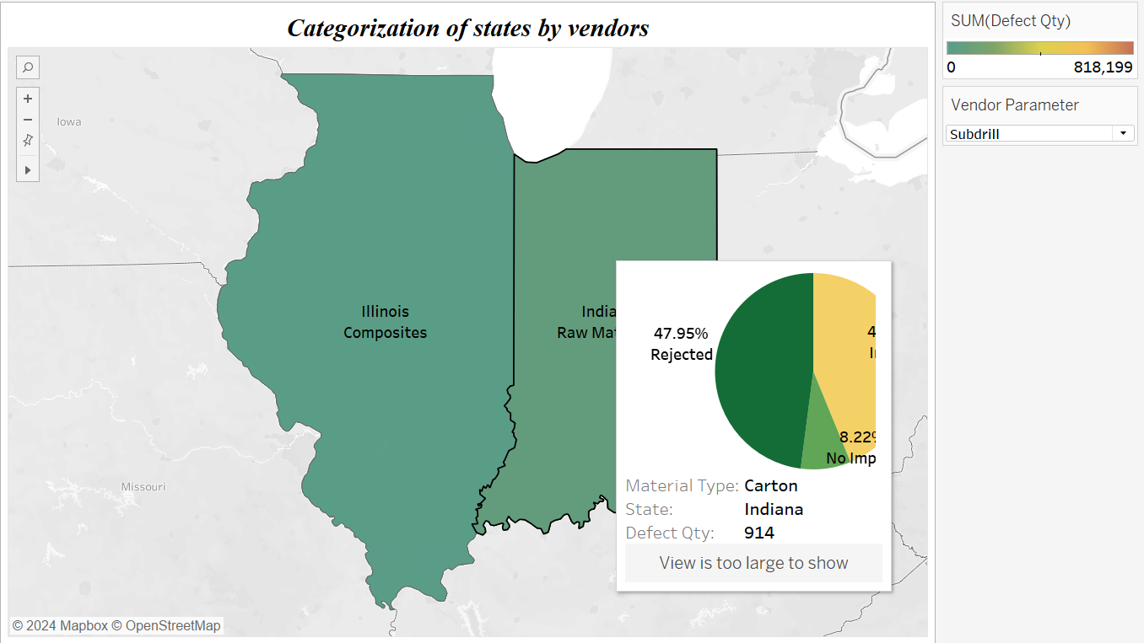

* 1. What is the impact of downtime on production?
* Downtime impact on production: Increased defect quantities in the first three quarters of the year correlate with higher downtime, impacting overall supply chain efficiency.

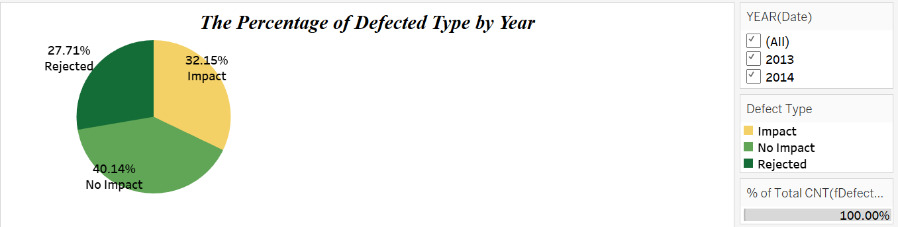

**Technical report**

# Outline methods and tools:

1. **Data Exploration 🡪 Google – ChatGPT - Gemini**
2. **Data Profiling**
3. **Data Cleaning 🡪 Microsoft Excel**
4. **Data Transformation 🡪 Power Query**
5. **Data Modeling🡪 Power Query**
6. **Data Visualization 🡪 Tableau**
7. **Reporting 🡪 Microsoft Word – Gemini – ChatGPT**

# Data source:

**Data Source:** The company **“obviEnce”** created this sample using real, anonymized data.

**Characteristics:**

* Simple data for supply chain in six states in the United States of America.
* Consists of seven tables which are divided into one fact table (Defected Items) and six dimensions.
* This data consists of 5649 rows (after cleaning).

# Descriptive statistics:

|  |  |
| --- | --- |
| ITEMS | AGGREGATION |
| Total number of cities | **24** |
| Total number of states | **6** |
| Total number of vendors | **326** |
| Total number of material types | **22** |
| Total number of defect types | **271** |
| Total number of defect quantity | **54,539,216** |
| Total number of downtime hours | **2,305** |
| The highest defect Quantity by vendor | **“Solholdings” 🡪3,977,962** |
| The highest downtime by vendor | **“Plustax” 🡪172.2 hour** |
| The highest defect quantity by category | **“Mechanicals” 🡪16,989,072** |
| The highest downtime hours by category | **“Logistics” 🡪932** |
| The highest defect quantity by state | **“Illinois” 🡪22,775,873** |
| The highest downtime hours by state | **“Michigan” 🡪442.9 hour** |
| The highest percentage defect quantity by material type | **“Raw Materials” 🡪24.24% 🡪(13,218,621)** |
| The lowest percentage defect quantity by material type | **“Valves” 🡪0.01% 🡪(5,696)** |
| The highest defect quantity by months | **“October 2014” 🡪5,087,899** |
| The lowest defect quantity by months | **“August 2013” 🡪712,815** |

# Data Cleaning Steps:

1. **Rename Sheets**

Defected Items>> fDefected Items (Fact-Table)

Category>> dCategory (Dimension-Table)

Plant>> dPlant (Dimension-Table)

Vendor>> dVendor (Dimension-Table)

Material>> dMaterial (Dimension-Table)

Defect Type>> dDefect Type (Dimension-Table)

Defects>> dDefects (Dimension-Table)

**2-Changes**

-Category sheet: deleting the ‘Category’ Column to avoid duplicates.

-Plant sheet: Splitting columns to ‘Plant’ column & ‘State’ column.

-Vendor sheet: - we used PROPER for the ‘Vendor’ Column.

-We made a ‘Vendor’ Column follows ‘Vendor ID’.

-Defect Type sheet: deleting the ‘Sort’ Column.

-Material Type sheet: We made a ‘Material Type’ column follows ‘Material Type ID’.

-Defect Type sheet: We made a ‘Defect Type’ column follows ‘Defect Type ID’.

-Defect sheet: We made a ‘Defect’ column follows ‘Defect ID’.

3-Replacing

|  |  |
| --- | --- |
| Ddefects sheet | Fdefected Items sheet |
| 3,4,99,206 | 2 |
| 299 | 271 |
| 265 | 38 |
| 201,151 | 149 |
| 260 | 180 |
| 168,279 | 111 |
| 284 | 112 |
| 240 Leaking doesn’t exist in Fact table Fdefected item | … |
| 212 | 163 |
| 178 | 144 |
| 298 | 51 |
| 249 | 62 |
| 247 | 227 |
| 303 | 217 |
| 304 | 192 |

* For Every number in the dimension table we delete it from the column to avoid any duplicates and replace dimension table numbers in the fact table.
* We found 193 duplicated rows in fdefected Items table 🡪so it’s a must to remove them.
* We found a blanck downtime row of vendor id 🡪810

# Data Transformation with Power Query in EXCEL:

fDefected Items

* Column ‘Date’ changing

(Data Type: to short date), (Data Format: to MM/DD/YYYY).

* Column ‘Downtime min’ changing

(Data Type: to Whole number)

* **TRIM** function used in ‘dPlant’ in the ‘State’ column to remove blank spaces.
* Replace the name of the ‘Sub-Category’ column with ‘Category’ in fDefected Items & dCategory sheets.

# Data Modeling:

* A new table named dCalendar
* Separate columns for (Day/Month/Month Number (Data type: whole number/Year/Day of week) & Quarter
* By using the **CELLING** function.
* other columns are text data types.

# Diagram View using EXCEL:

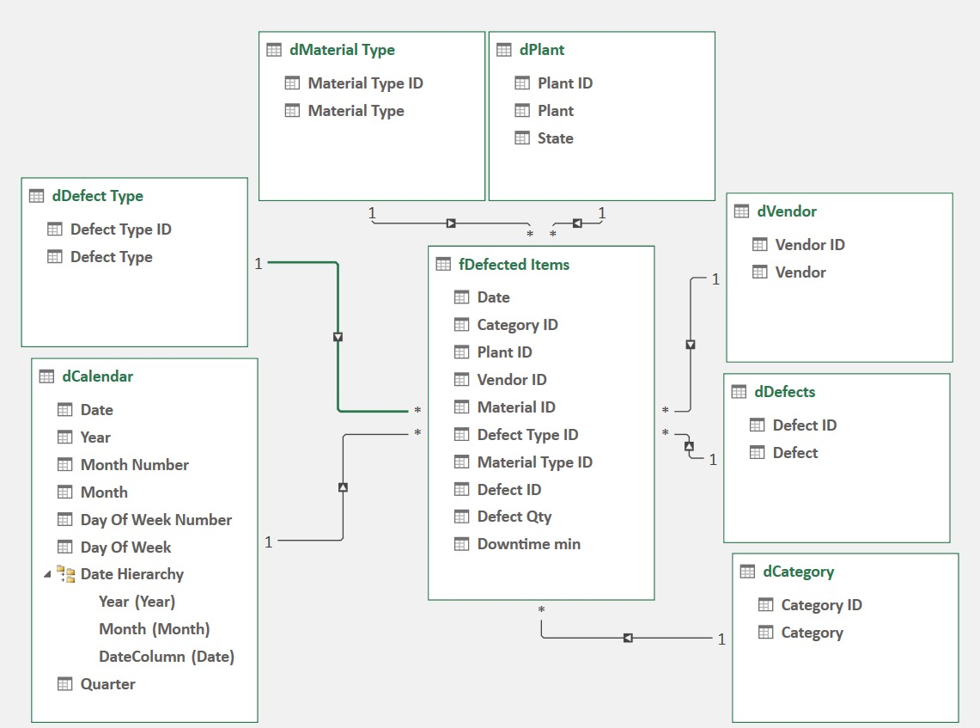

* This diagram discusses the relation between fDefected table the fact table & the other dimensions (dDefected Type/dCalendar/dVendor/dCategory/dDefects/dPlant/dMaterial Type)
* dDefect Type: Defect Type ID (Primary Key) & (Foreign Key in fDefected Items
* dCalendar: Date (Primary Key) & (Foregin Key) in fDefected Items
* dVendor: Vendor ID (PK) & (FK) in fDefected Items
* dCategory: Category ID (PK) & (FK) in fDefected Items
* dDefects: Defects ID (PK) & (FK) in fDefected Items
* dPlant: Plant ID (PK) & (FK) in fDefected Items
* dMaterial Type: Material ID (PK) & (FK) in fDefected Items

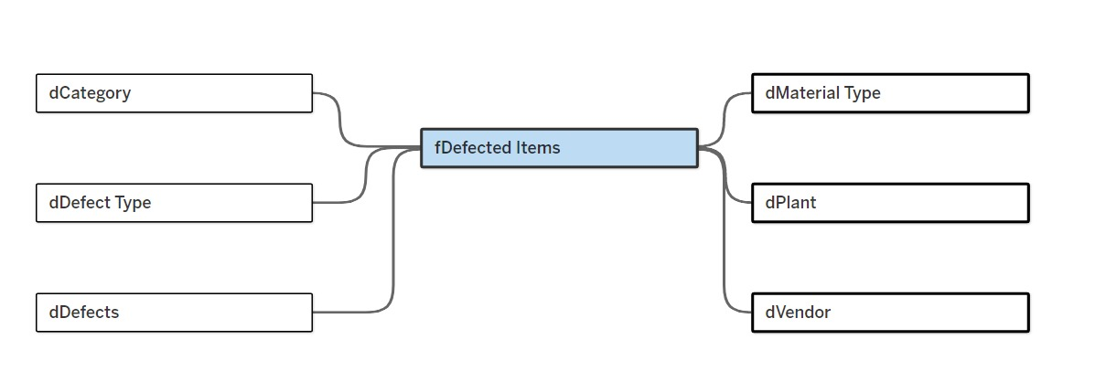

* Renaming tables by their original names instead of counting to
* (Downtime min hrs): as a new measure in Fdefected items
* By Div(downtime,60)

# Parameters and calculated fields:

1-Material Type Parameter:

**Parameter Description**:

The "Material Type" parameter is used to filter and control the visibility of data based on the specific type of material being analyzed. This parameter is particularly in scenarios where you want to focus on a particular category of materials or compare different material types.

**Data Type**: The data type for this parameter is **String**, indicating that it accepts text values.

**Valid Values**: The parameter includes a list of predefined values that represent different material types:

* Corrugate: Corrugated cardboard or paper
* Film: Plastic or other thin sheet materials
* Carton: Cardboard boxes or containers
* Composites: Materials made from a combination of different materials
* Controllers: Electronic devices used to regulate or control other devices
* Drives: Mechanical or electronic devices used to transmit power
* Electrolytes: Substances that conduct electricity when dissolved in a solvent
* Raw Materials: Basic materials used in manufacturing processes
* Labels: Adhesive labels or stickers
* Hardware: Mechanical parts or components
* Mechanicals: Mechanical devices or systems
* Glass: Glass products, such as windows, bottles, or lenses
* Molds: Tools or forms used to shape materials
* Motors: Electric motors used to power machinery
* Pump: Devices used to move fluids
* Packaging: Materials used to package products
* Tape: Adhesive tape or strips
* Valves: Devices used to control the flow of fluids or gases
* Printed Materials: Printed materials, such as books, magazines, or brochures
* Crates: Wooden or plastic containers used for shipping or storage
* Wires: Electrical wires or cables

**Example Use Cases:**

1. **Comparing defect rates:** Analyze defect quantity for different material types to identify areas for improvement.
2. **identify vendor:** To identify the vendors who supply each material independently

2-State Parameter:

**Parameter Description**: The "State" parameter is used to filter and control the visibility of data based on the specific state or region being analyzed. This parameter is particularly useful in scenarios where you want to focus on data from a particular region or compare data across different states.

**Data Type**: The data type for this parameter is likely **String**, indicating that it accepts text values. This is appropriate for categorizing data based on state names.

**Valid Values:** The parameter includes a list of predefined values representing the states you want to include in your analysis:

* Illinois
* Iowa
* Michigan
* Ohio
* Wisconsin
* Indiana

**Example Use Cases:**

1. Regional Analysis: Compare performance across different states to identify performing regions.
2. Correlation: To find the Correlation between defect qty and downtime hours

3-Vendor Parameter:

**Parameter Description**: The "Vendor" parameter is used to filter and control the visibility of the specific vendor involved, This parameter is particularly useful in scenarios where you want to focus on data from a particular vendor or compare the performance of different vendors.

**Data Type**: The data type for this parameter is likely **String**, indicating that it accepts text values. This is appropriate for categorizing data based on vendor names.

**Valid Values**: The parameter includes a list of predefined values representing the Vendor name you want to include in your analysis.

**Example Use Cases:**

1. **Vendor Performance Analysis:** Compare the performance of different vendors in defect quantity, downtime, and performance in different States.
2. **Supplier Risk Assessment:** Identify vendors with high-risk factors, such as defect quantity or downtime issues.
3. The number of defective items due to each vendor by material type

Calculated Field

## 1-Material calc:

## **Analyzing the Calculated Field**: [Material Type Parameter] = [Material Type]

Purpose: This calculated field is likely used to filter data based on the selected value of the "Material Type" parameter. It compares the value of the "Material Type" parameter to the actual "Material Type" field in your dataset.

**Breakdown:**

* [Material Type Parameter]: This refers to the value selected by the user for the "Material Type" parameter. It's a dynamic value that can change based on the user's input.
* [Material Type]: This refers to the actual "Material Type" field in your dataset, containing the specific material type for each data point.
* =: The equal sign operator compares the two values.

**How it Works:**

The calculated field will return a Boolean value (TRUE or FALSE) for each data point:

* TRUE: If the value in the "Material Type" field matches the selected value of the "Material Type" parameter.
* FALSE: If the value in the "Material Type" field does not match the selected value of the parameter.

**Use Cases:**

* Filtering Data: You can use this calculated field as a filter to display only data points where the "Material Type" matches the selected value from the parameter.
* Creating Calculated Fields: You can use this calculated field in other calculations to perform conditional logic or aggregate data based on the "Material Type."
* Highlighting Specific Data: You can use this calculated field to highlight data points that belong to a specific material type in visualizations.

2-State Calc

**Analyzing the Calculated Field**: [State Parameter]=[State]

Purpose:

This calculated field is likely used to filter data based on the selected value of the "State" parameter. It compares the value of the "State" parameter to the actual "State" field in your dataset.

**Breakdown:**

* [State Parameter]: This refers to the value selected by the user for the "State" parameter. It's a dynamic value that can change based on the user's input.
* [State]: This refers to the actual "State" field in your dataset, containing the state or region for each data point.
* =: The equal sign operator compares the two values.

**How it Works:**

The calculated field will return a Boolean value (TRUE or FALSE) for each data point:

* TRUE: If the value in the "State" field matches the selected value of the "State" parameter.
* FALSE: If the value in the "State" field does not match the selected value of the parameter.

Use Cases:

* Filtering Data: You can use this calculated field as a filter to display only data points from the selected state.
* Creating Calculated Fields: You can use this calculated field in other calculations to perform conditional logic or aggregate data based on the "State."
* Highlighting Specific Data: You can use this calculated field to highlight data points from a specific state in visualizations.

## 3- vendor calc

## **Analyzing the Calculated Field**: ([Vendor Parameter]) = [Vendor]

Purpose:

This calculated field is likely used to filter data based on the selected value of the "Vendor" parameter. It compares the value of the "Vendor Parameter" to the actual "Vendor" field in your dataset.

**Breakdown:**

* [Vendor Parameter]: This refers to the value selected by the user for the "Vendor" parameter. It's a dynamic value that can change based on the user's input.
* [Vendor]: This refers to the actual "Vendor" field in your dataset, containing the vendor name for each data point.
* =: The equal sign operator compares the two values.

**How it Works:**

The calculated field will return a Boolean value (TRUE or FALSE) for each data point:

* TRUE: If the value in the "Vendor" field matches the selected value of the "Vendor" parameter.
* FALSE: If the value in the "Vendor" field does not match the selected value of the parameter.

**Use Cases:**

* Filtering Data: You can use this calculated field as a filter to display only data points from the selected vendor.
* Creating Calculated Fields: You can use this calculated field in other calculations to perform conditional logic or aggregate data based on the "Vendor."
* Highlighting Specific Data: You can use this calculated field to highlight data points from a specific vendor in visualizations.

Measures

Key Measures:

1- Total Defect Quantity:

* Description: The total number of defects quantity
* Calculation: Sum of all defect quantities recorded for each day.
* Aggregation: Can be aggregated by vendor, downtime, material type, category,or state

2- Time Down :

* Description: The total amount of time lost due to issues related to defect quantity
* Calculation: Sum of all downtime periods attributed to defects
* Aggregation: Can be aggregated by vendor, downtime, material type, category,or state

3-Date

**is a crucial measure in supply chain analysis, especially when combined with defect quantity and downtime data.** By tracking these metrics over time, you can gain valuable insights into the performance of your supply chain and identify areas for improvement.

Here are some specific ways to use "date" in conjunction with defect quantity and downtime:

### 1. Defect Quantity Over Time:

* Calculation: Calculate the defect quantity for specific periods (e.g., daily, weekly, monthly).
* Analysis: Identify trends in defect rates, such as increasing or decreasing over time. This can help pinpoint root causes and implement corrective actions

### 2- Downtime Analysis:

* Calculation: Track the duration and frequency of downtime events over time.
* Analysis: Identify the primary causes of downtime and their impact on quantity defects.

### 3- Correlation between Defects and Downtime:

* Analysis: Examine if there is a correlation between the occurrence of defects and downtime events. This can help identify whether defects are a significant contributor to downtime or if other factors are more influential.

### 4- Root Cause Analysis (RCA):

* Investigation: Use data on defects, downtime, and dates to conduct RCA investigations.
* Identification: Identify the underlying causes of defects and downtime, which can often be traced back to specific periods or events.

### 5- Vendor Performance Evaluation:

* Assessment: Track defect rates and downtime for specific vendors over time.
* Comparison: Compare the performance of different vendors to identify those with the best quality.

### 6- Continuous Improvement:

* Data-driven decisions: Use date-based metrics to make data-driven decisions for continuous improvement initiatives.
* Problem-solving: Identify and address recurring issues that impact quality and productivity.

7- Forecasting:

* Seasonal Patterns: Incorporate historical of time down and defect quantity (dates and quantities) to identify seasonal patterns
* Forecasting Models: Use forecasting models (e.g., time series analysis) to predict future downtime and defect quantity based on historical data.

**Insights & Performance**

# Insights:

1. **Vendor concentration in defects:** **46%** of the total defect quantity is supplied by just **10** vendors, with a significant impact from vendor downtime.
2. **Illinois’ major role in defects:** **Illinois**, with **190** vendors, contributes the highest defect quantity (**22.7 million**), driving a **647**-hour increase in downtime. This is tied to Illinois' diverse economy, including finance, agriculture, and manufacturing.
3. **Logistics as a downtime driver:** **Logistics**, affected by transportation delays, inventory issues, and supply chain disruptions, account for the most downtime hours.
4. **Illinois logistics delays:** Delays in **Illinois** account for **39%** (250 hours) of downtime, largely due to logistical challenges.
5. **Mechanical defects: Mechanical** issues are the leading source of defects, especially in states like **Michigan, Indiana, and Ohio**, which are hubs for **automotive** and **aerospace** manufacturing.
6. **Regional defect risks:** The Midwest’s industrial belt, with its long supply chains and complex manufacturing, is prone to **higher** defect rates due to the **complexity** of products.
7. **Quarterly defect trends:** Defect quantities and downtime **peak** in **Q3** and **decline** in **Q4**, indicating a correlation between increased production volume and downtime.
8. **Unique vendor performance:** **Subdrill**, a vendor in Indiana, maintains **zero** defects and downtime over **three** supply orders, whereas **Conzumzap** has the **highest** defect quantity in a single supply order.
9. **Downtime impact on production:** **Increased** defect quantities in the first **three** quarters of the year correlate with **higher** downtime, impacting overall supply chain efficiency.

# Recommendations:

**Address Vendor Concentration Issues:**

Focus on the top 10 vendors responsible for 46% of defect quantities. Implement vendor improvement plans including regular audits, defect root cause analysis, and performance-based incentives to reduce defect quantities and downtime.

**Diversify vendor reliance:**

Reduce the dependency on high-defect vendors by exploring partnerships with new, lower-defect suppliers to balance the supply chain.

**Optimize Illinois-Based Operations:**

Given that Illinois contributes a significant share of defects (22.7 million), prioritize improvements for Illinois-based vendors. Conduct detailed analyses of each vendor to identify those with the highest defect rates and downtime hours.

Develop tailored improvement programs for vendors in high-impact industries (finance, agriculture, manufacturing) to address specific challenges they face.

**Logistics Downtime Mitigation:**

Enhance logistics efficiency by investing in real-time tracking systems and predictive analytics to better anticipate transportation delays and inventory issues.

Partner with logistics providers to create contingency plans for disruptions and invest in smarter routing to avoid delays in high-traffic regions.

**Address Illinois Logistics Delays:**

Collaborate with logistics providers in Illinois to reduce transportation delays and mitigate the 39% downtime caused by logistics. Implement optimized inventory management systems to reduce overstocking or shortages.

Redesign supply chain processes to improve transportation efficiency in the Illinois region, potentially including local warehousing or transportation hubs to streamline operations.

**Mechanical Defects Prevention:**

Enhance quality control for mechanical parts, especially in key industries like automotive and aerospace manufacturing in Michigan, Indiana, and Ohio. Introduce preventive maintenance programs and encourage vendors to adopt new technologies for early detection of mechanical issues.

Collaborate with manufacturers to simplify production processes where possible, reducing the complexity that contributes to mechanical defects.

**Mitigate Regional Defect Risks:**

For Midwest vendors, streamline supply chains by minimizing transit times and distances, which reduces the chances of product damage. Improve packaging and handling protocols to prevent defects during shipping.

Consider localizing parts of the supply chain to minimize the length and complexity of transportation, reducing defect risks tied to logistics.

**Manage Quarterly Production Spikes:**

To address peak defect quantities in Q3, optimize production scheduling to avoid overloading vendors and ensure adequate workforce capacity. Implement seasonal workforce training to address potential lapses in production quality.

Use predictive analytics to manage supply chain risks proactively during high-production periods and balance workloads more effectively across the year.

**Leverage Vendor Best Practices:**

Use Subdrill’s zero-defect performance as a benchmark for other vendors. Analyze Subdrill’s processes and share best practices across the supply chain.

For vendors like Conzumzap with high defect rates, introduce a corrective action program that includes focused training, audits, and performance tracking to improve future orders.

Suppliers must be evaluated at short intervals to ensure that the obstacle is resolved as soon as it is known.

**Align Production with Downtime Management:**

Since higher defect quantities are correlated with increased downtime, focus on reducing production disruptions by investing in automation and improving supplier quality.

Implement downtime reduction strategies across the supply chain, such as real-time monitoring systems, faster decision-making protocols, and predictive maintenance, to maintain production efficiency throughout the year.

**Limitations**

* 1. **The data is poor in financial information that helps in evaluation in a basic way.**
  2. **There are no technical and financial specifications based on which suppliers are selected.**
  3. **Data storage occurred randomly, leading to the loss of important data and the addition of a lot of redundant data.**